CSE421 LAB 02

HTTP REQUEST

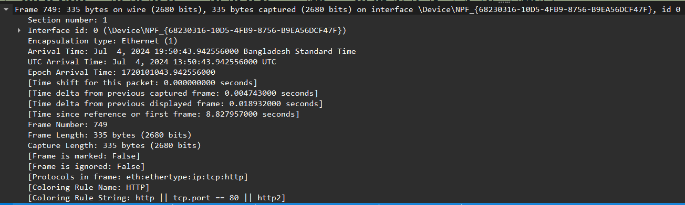

Here, in frame details we can see an Ethernet packet containing an HTTP request, arriving on the specified interface at a precise timestamp. The packet includes 335 bytes of data and follows the protocols Ethernet, IP, TCP, and HTTP, with a coloring rule applied for HTTP traffic.



This Ethernet frame encapsulates an IPv4 packet, sent from the source MAC address 8c:b8:7e:f5:83:e0 (Intel) to the destination MAC address 0a:ce:5c:94:2c:7a. The Ethertype field indicates the payload is an IPv4 packet (0x0800).

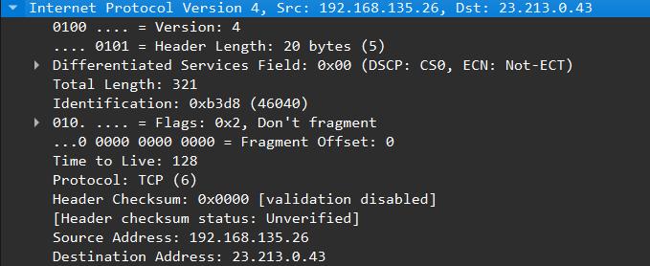

This is an IPv4 header for a packet with a total length of 321 bytes, containing a TCP segment. The packet is sent from 192.168.135.26 to 23.213.0.43 with a TTL of 128 and is set not to be fragmented.

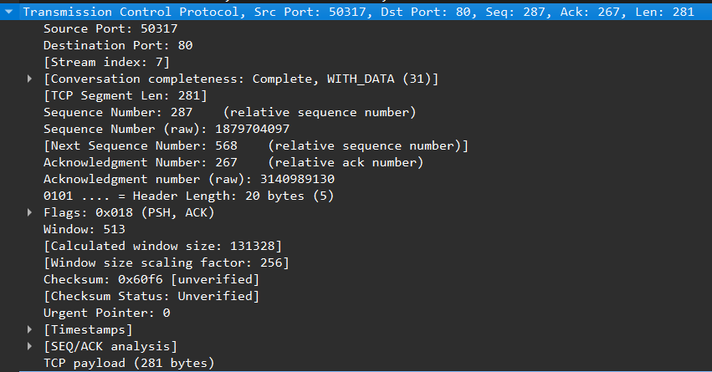

This TCP segment is part of an HTTP request, carrying 281 bytes of data from the client (source port 50317) to the server (destination port 80). It includes sequence and acknowledgment numbers.

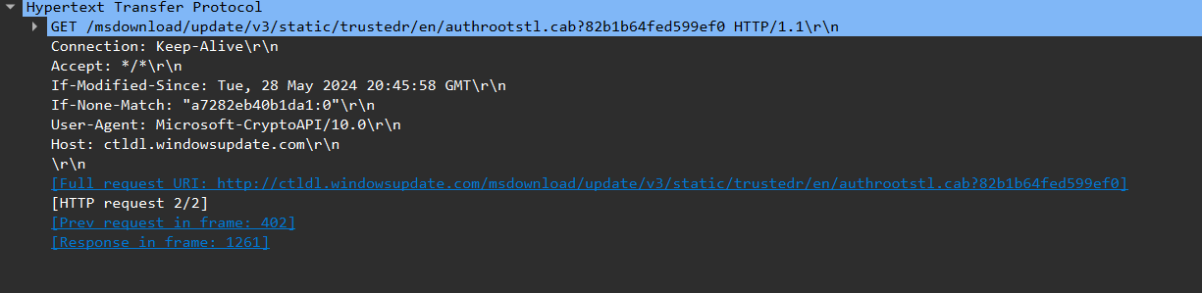

This HTTP request is checking if a cached version of a file from the server is still valid.The client uses these to determine if it needs to download a new version of the file.

Http Response

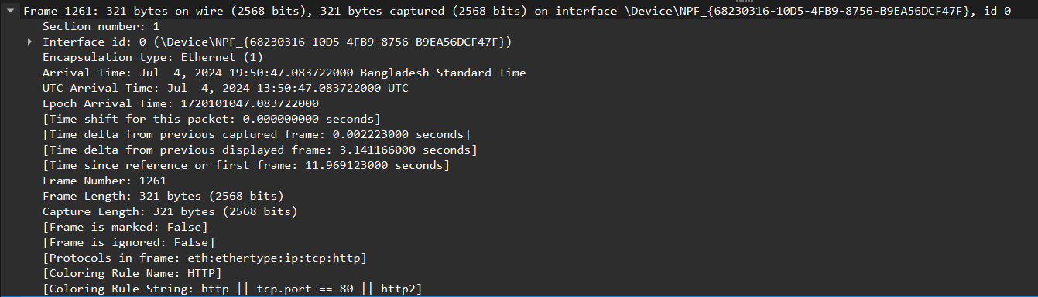

This network capture frame logs an Ethernet packet with an HTTP request, including timestamps, frame size, and protocol details, arriving on the specified interface.



This Ethernet frame, containing an IPv4 packet, is sent from the source MAC address 0a:ce:5c:94:2c:7a to the destination MAC address 8c:b8:7e:f5:83:e0.

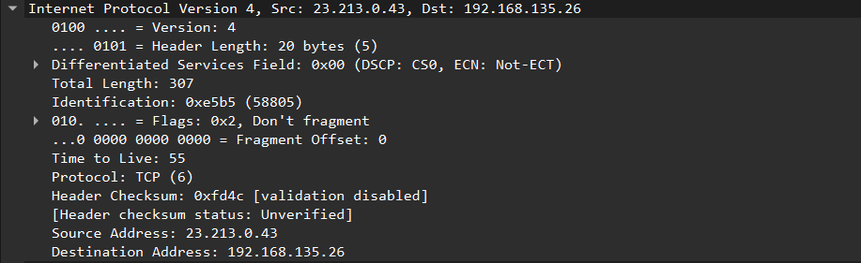

This is an IPv4 header for a packet of 307 bytes, with the TCP protocol, sent from 23.213.0.43 to 192.168.135.26, set to not be fragmented and with a TTL of 55.

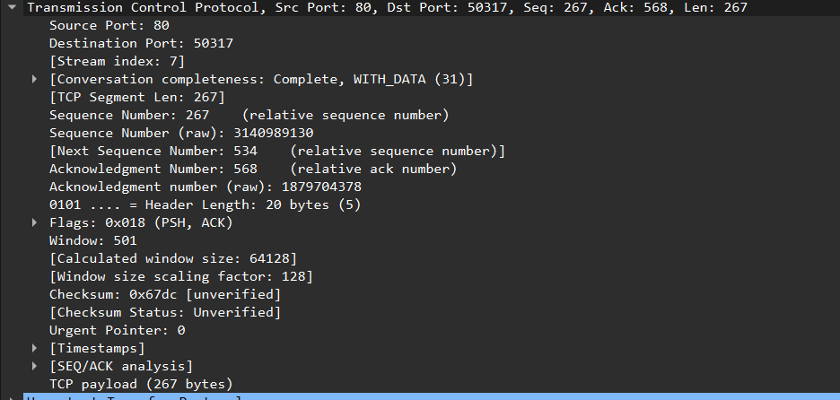

This TCP segment represents data being sent from port 80 (source) to port 50317 (destination), acknowledging sequence number 568 and carrying 267 bytes of payload data.

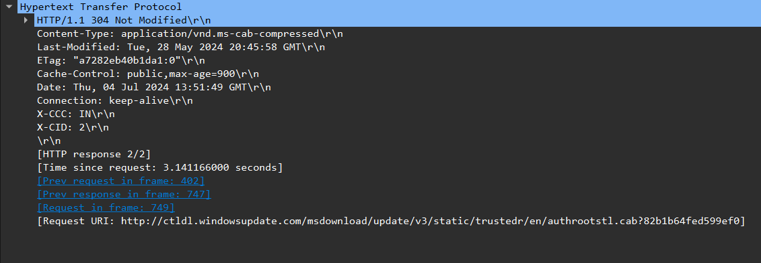

This HTTP response indicates that the requested resource has not been modified since the specified date, returning a 304 status code along with metadata about the resource and caching directives.